

Guidance Document: Safeguarding Register

What is the Safeguarding Register?
The Safeguarding Register (Register) is an electronic tool to record details of the Working with Children Check and Safeguarding education details of Parish and/or Chaplaincy Workers who are engaged in Child-Related roles. The Parish and/or Chaplaincy Worker can be a Volunteer or Employee. The Register assists the Parish Priest/Administrator/Chaplain to fulfil his legislative requirements applicable to both the Children’s Guardian Act 2019 and the Child Protection (Working with Children) Act 2012.
This guide provides an overview of the information that must be entered into the Register for monitoring and maintaining purposes and the information from the Register that needs to be submitted to the Safeguarding Office for audit purposes.

What is a Child Related Role?

We acknowledge that ministry looks very different in Parishes and Chaplaincy Communities across the Archdiocese and it is important to recognise this. The information below provides guidance and must be interpreted in terms of the specific details of each role carried out in the Parish and/or Chaplaincy.
- Parish Secretaries
- Safeguarding Support Officer
- Children’s Liturgy Coordinator and Leader
- Sacramental Coordinator and Group Leader
- Youth Ministry Coordinator and Leader
- Children’s Choir Ministry Leader
- Parish run playgroups – Coordinator and Supervisor
- Pastoral Associate
- Acolytes and Senior Altar Servers
- SRE Teachers
- Eucharistic Ministers

Purpose of the Register

It is a legal obligation to hold records relating to those Workers within the Parish and/or Chaplaincy that are engaged in Child-Related roles and to ensure that the information is up to date. Penalties apply for breaching the Child Protection (Working with Children) Act 2012 and this Register assists in maintaining correct data. An electronic template of the Register is available on the Parish Support Intranet which must be used.
Under Section 9 (1) (a) of the Child Protection (Working with Children) Act 2012, an Employer faces a substantial fine of up to $5,500 for an individual (i.e. 50 penalty units) or $11,000 for a corporation (i.e. 100 penalty units) if they employ a person who is required to obtain a WWCC but know or have reasonable cause to believe, that the person does not hold one.

Information held on the Register

The Register, at a minimum, shall contain the following information:

- Name of worker (Employee or Volunteer)

- Date of Birth

- WWCC Number

- WWCC expiry date

- Verification Date (via the Office of the Children’s Guardian online
PORTAL)

- Verification outcome

- Code of Conduct

- Role/Ministry Title

- Paid or volunteer work

- Online Induction Education (Salt) Completion Date

- In Person Education (selected personnel) Completion Date

- Online Refresher Education (SALT) Completion Date

Additional columns can be added to the template as required by the Parish and/or Chaplaincy, this information can easily be “hidden” when submitting the Register to the Safeguarding Office. This can be done by selecting all columns within your Register that are not required as part of the audit.
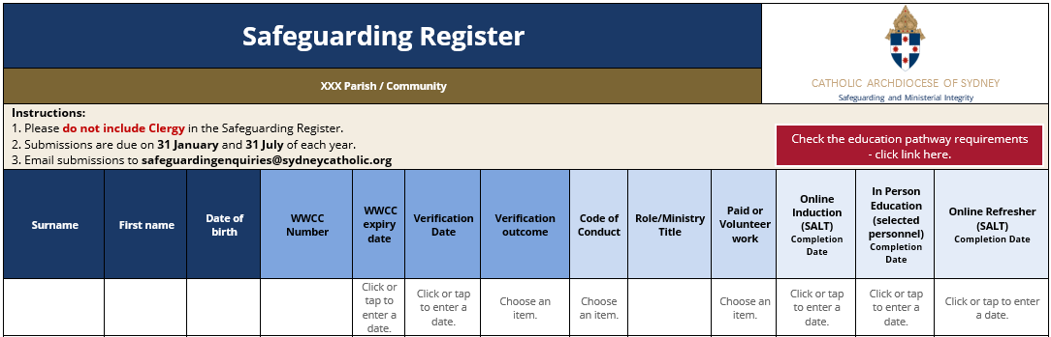

Details of Clergy appointed to the Parish and/or Chaplaincy and visiting Clergy are not to be placed on the Register. The Chancery Office retains applicable data for all Clergy.

WWCC details for Special Religious Education (SRE) teachers are to be maintained on the Register. WWCC’s for SRE teachers are verified via the Office of the Children’s Guardian online PORTAL by the Parish and/or Chaplaincy and all training requirements are managed by the Confraternity of Christian Doctrine (CCD).

Monitoring and maintaining the Register

New Worker (Volunteer and Employee) in a Child related role: Before a Worker can begin working with Children, their WWCC must be verified via the Office of the Children’s Guardian online PORTAL and recorded in the Register. They can only start work once they hold a valid and verified WWCC.

Mandatory Reporting and the Reportable Conduct Scheme: It is legislated that Employers (Parish Priest/Administrator/Chaplain) inform Workers of the legal obligations that apply to them if they work in Child-Related activities. A date recorded on the Register will indicate when the Parish and/or Chaplaincy Worker was informed of the requirements associated with reporting and workplace behaviour towards Children.
Safeguarding Induction & Refresher Education: At the time of verifying the WWCC of the new Worker on the Office of the Children’s Guardian online PORTAL, the Parish and/or Chaplaincy Office must register the Worker for the Online Safeguarding Induction Education. Alternatively, the Worker can register themselves for the Online Safeguarding Induction Education. You must follow up with the Worker to ensure they have registered and completed the Safeguarding Induction Education course. The Parish Priest, Administrator, or Chaplain will receive a monthly emailed report identifying any Workers who have registered but have not completed, or are overdue in completing, the Online Safeguarding Induction or Refresher Education for that month. Safeguarding Refresher Education is required every two (2) years from the date the Safeguarding Induction Education course is completed.
Please note: Safeguarding Induction Education for SRE teachers is facilitated by the CCD and CCD retain the applicable data for all SRE teachers. The Parish and/or Chaplaincy can enter the following descriptor for SRE teachers in the Induction Column of the Register – CCD Compulsory Course.
Safeguarding Education: A schedule of Safeguarding Education is available on the Safeguarding Office website. It is the responsibility of the Parish Priest/Administrator/Chaplain to inform those Workers who require additional Safeguarding Education of their obligation to attend Safeguarding Education Attendance of Workers will be recorded on the Register by the Parish and/or Chaplaincy Office.
Expiry of WWCC: A Worker in a Child-Related role cannot legally work with Children if they do not have a valid and verified WWCC. The Register assists in identifying the validity of the checks. It is imperative that an alert system is in place that notifies the Parish and/or Chaplaincy Office when a WWCC is due to be renewed (within 3 months) or has expired. There are penalties that apply to the Parish and Chaplaincy for non-compliance. The renewed WWCC needs to be verified on the Office of the Children’s Guardian online PORTAL.

OCG Notification: If the Parish Priest/Administrator/Chaplain receives a letter or email advising that a current or past Employee or Volunteer has become barred (or has an interim bar) they must immediately be removed from Child-Related work. The Register must also be adjusted accordingly. The status of the WWCC outcome is to be changed to either Barred or Interim Bar. The Safeguarding Office must be informed immediately.
Please Note: For SRE teachers CCD must also be advised.

Archiving: The template provides an Archive Tab. If you identify anyone that previously held a verified WWCC by the Parish and/or Chaplaincy and is still active in a role, but you have now assessed this role as not being Child-Related (by law) these Workers’ details must be maintained under the archive tab permanently. Workers who have previously held a role requiring a WWCC but are no longer active, and do not fall under the new legislation are to be archived also.
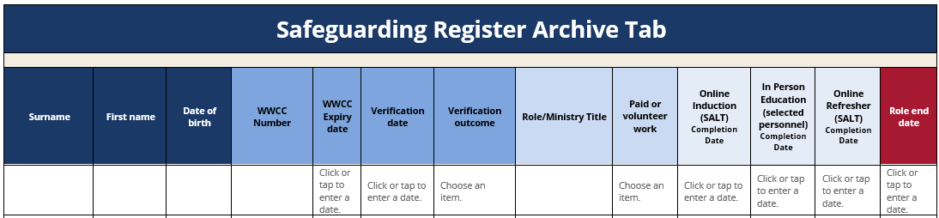

Safeguarding Register Audit

Bi-annual audits of the Safeguarding Register administered by the Safeguarding Office are scheduled for the following periods:
- 1 January to 30 June (inclusive). The due date of the Register is 31 July and;
- 1 July to 31 December (inclusive). The due date of the Register is 31 January.
In preparation for the census the delegated Parish and/or Chaplaincy personnel will ensure data recorded is up to date.

Related Documents:

- Protocol: Safeguarding Register
- Excel Spreadsheet: Safeguarding Registers Template
- Fact Sheet: Who needs a Working with Children Check
- Guidance Document: Who must obtain a Working with Children Check?
- Protocol: Screening of Workers
- Fact Sheet: What is Child-Related Work?
- Protocol: Mandatory Safeguarding and Child Protection Education

